Parents and Guardians of Mabelvale Middle School,

We need your support with your student taking proper care of his/her technology device. Students are damaging or losing their iPad daily. Please review the following with your student:

* Never place an iPad in a book bag that contains food, liquids, heavy or sharp objects.
* Avoid getting moisture in the openings.
* Never leave your iPad unattended.
* Keep in a safe place at school/home.
* Keep the iPad in its protective case.
* No playing with device in hand.
* Never throw or slide the iPad.
* Do not lend your iPad to another person.
* Report any lost iPad to your teacher and he or she will email Kelly or Ledbetter.
* Do not use Safari to install apps, use Self- Service ONLY.
* The iPad is designed for daily use; therefore, each iPad must be fully charged and ready for use each school day.
* Keep up with your charger, cost $10.

We are asking that you place insurance on iPads to avoid the cost of $320 for lost or damaged devices. The link and steps for the insurance are listed below.

<https://lrsd1.schoolcashonline.com/>This is the link for insurance, iPads = $34. 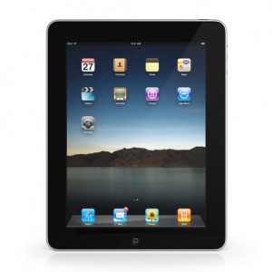 The deadline for insurance is November 1, 2021.

Directions for using SchoolCash Online:

1. Register at SchoolCashOnline, use the link above
2. Create a Parent Profile/Account
3. Check the email to confirm the profile/account
4. Add students to that profile/account. You will need the student identification number for this step.
5. Choose iPad insurance
6. Choose Mabelvale Middle School
7. Complete the check- out